CS 255 Business Requirements Document Template

DriverPass System Design Requirements
Carrie Cummings

System Components and Design

Purpose
What is the purpose of this project? Who is the client and what do they want their system to be able to do?
- The purpose of this project is to design a web-based DriverPass system that supports online driver-training preparation and on-the-road lesson scheduling.
- The client is DriverPass, a company created by Liam to address the gap between students studying old driving tests and students receiving actual, current driving-test preparation.
- The completed system should allow customers to create accounts, choose training packages, take online classes and practice tests, schedule driving lessons, track progress, and communicate with DriverPass staff.
- The project should also support DriverPass employees, including the owner, IT officer, secretary, and drivers, so they can manage appointments, reports, user access, training content, and customer information.

System Background
What does DriverPass want the system to do? What is the problem they want to fix? What are the different components needed for this system?
- DriverPass identified a problem in driver education: many students are failing DMV driving tests because they rely mainly on previous tests instead of structured training and current DMV-aligned preparation.
- DriverPass wants to solve this problem by offering a system that combines online classes, practice exams, and optional on-the-road training with professional drivers.
- The system must support customer registration, package selection, lesson scheduling, online testing, driver notes, reporting, account management, and communication with students.
- The system must connect to DMV-related updates so DriverPass can receive notifications about new rules, policies, or sample questions and keep training content current.
- The system should run over the web and preferably in the cloud so DriverPass can focus on running the business rather than managing backups and security internally.

Objectives and Goals
What should this system be able to do when it is completed? What measurable tasks need to be included in the system design to achieve this?
- Provide customers with online account access from computers and mobile devices.
- Allow customers to select one of three training packages and schedule driving lessons online.
- Allow the secretary to create, modify, and cancel appointments on behalf of customers who call or visit the office.
- Track the customer, driver, vehicle, date, time, pickup location, and drop-off location for every driving lesson reservation.
- Display online test progress, including test name, time taken, score, and status.
- Display driver notes, including lesson time, start hour, end hour, and driver comments.
- Allow authorized staff to generate activity reports showing who created, modified, or canceled reservations.
- Provide role-based access so the owner, IT officer, secretary, drivers, and customers have appropriate system permissions.
- Provide a realistic project schedule with prioritized tasks, dependencies, and time allocations from requirements collection through sign-off.

Requirements

Nonfunctional Requirements

Performance Requirements
What environments (web-based, application, etc.) does this system need to run in? How fast should the system run? How often should the system be updated?
- The system shall run as a web-based/cloud-supported system accessible through modern browsers on computers and mobile devices.
- The system shall allow authorized users to access data online from any supported device, while preventing offline updates that could create duplicate or inconsistent records.
- The system shall support timely scheduling, account access, reporting, and test progress retrieval without unnecessary delays during normal business use.
- The system shall allow reports and selected information to be downloaded for offline review, such as use in Excel, while requiring online access for edits and updates.

Platform Constraints
What platforms (Windows, Unix, etc.) should the system run on? Does the back end require any tools, such as a database, to support this application?
- The system shall be designed for browser-based access and cloud hosting rather than a locally installed desktop-only application.
- The back end shall require a database to store users, appointments, packages, vehicles, drivers, practice tests, test results, driver notes, and activity history.
- The system shall avoid local/offline data modification because DriverPass specifically wants to prevent duplicate data across different servers.
- The platform should allow integration with outside DMV update sources and support secure account/password management.

Accuracy and Precision
How will you distinguish between different users? Is the input case-sensitive? When should the system inform the admin of a problem?
- The system shall distinguish between customers, secretary users, drivers, the owner, and the IT officer using role-based permissions.
- The system shall track who creates, modifies, or cancels each reservation so DriverPass can review responsibility if an issue occurs.
- The system shall accurately associate each reservation with one customer, one driver, one vehicle, a date, a time, and pickup/drop-off location details.
- The system shall display test status using consistent values such as not taken, in progress, failed, and passed.
- The system shall prevent scheduling conflicts so the same driver, vehicle, or time slot is not double-booked.

Adaptability
Can you make changes to the user (add/remove/modify) without changing code? How will the system adapt to platform updates? What type of access does the IT admin need?
- The system shall allow the IT officer to maintain accounts, reset passwords, block access, and manage role permissions.
- The system shall allow DriverPass to disable training packages when Liam no longer wants customers to register for a specific package.
- The system shall be designed with future flexibility in mind, even though adding or removing major modules is considered future scope and may require developer support.
- The system shall support updates to DMV rules, policies, and practice materials by receiving notifications when updated content is available.

Security
What is required for the user to log in? How can you secure the connection or the data exchange between the client and the server? What should happen to the account if there is a “brute force” hacking attempt? What happens if the user forgets their password?
- The system shall require secure login credentials for all user accounts.
- The system shall provide an automatic password reset process for customers who forget their passwords.
- The system shall give the IT officer full administrative access to reset accounts and block access for former employees.
- The system shall protect customer personal and payment information, including credit card number, expiration date, and security code.
- The system shall use role-based security so users only access functions appropriate to their role.
- The system shall log reservation activity so changes can be reviewed through activity reports.

Functional Requirements
Using the information from the scenario, think about the different functions the system needs to provide. Each of your bullets should start with “The system shall . . .” For example, one functional requirement might be, “The system shall validate user credentials when logging in.”
- The system shall allow customers to register for an account by entering first name, last name, address, phone number, state, payment information, pickup location, and drop-off location.
- The system shall allow customers to log in and reset forgotten passwords automatically.
- The system shall allow customers to select from available DriverPass training packages.
- The system shall allow customers to make, modify, and cancel driving lesson reservations online.
- The system shall allow the secretary to make, modify, and cancel appointments for customers by phone or in person.
- The system shall assign each driving lesson reservation to a customer, driver, vehicle, date, time, pickup location, and drop-off location.
- The system shall allow customers in the appropriate package to access online class content and practice tests.
- The system shall show online test progress, including test name, time taken, score, and status.
- The system shall show driver notes, including lesson time, start hour, end hour, and driver comments.
- The system shall allow the owner to print or download reports, including activity reports.
- The system shall allow the IT officer to maintain user accounts and permissions.
- The system shall notify DriverPass when the DMV provides updated rules, policies, or sample questions.
- The system shall provide a contact page and a way for DriverPass to contact students.

User Interface
What are the needs of the interface? Who are the different users for this interface? What will each user need to be able to do through the interface? How will the user interact with the interface (mobile, browser, etc.)?
- The interface shall be web-based and accessible through supported browsers on computers and mobile devices.
- Customers shall be able to register, log in, reset passwords, select packages, schedule lessons, view test progress, and contact DriverPass through the interface.
- The secretary shall be able to enter or update customer information and schedule appointments on behalf of customers.
- Drivers shall be able to provide or view lesson-related comments and lesson timing information when authorized.
- The owner shall be able to view and download reports, including activity reports that show reservation changes.
- The IT officer shall be able to access administrative tools for account maintenance, password resets, access blocking, and permission management.
- The online test progress page shall display test name, time taken, score, and status.
- The driver notes page shall display lesson time, start hour, end hour, and driver comments.
- The interface should use clear labels, consistent navigation, and plain language so users can complete core tasks without unnecessary confusion.

Assumptions
What things were not specifically addressed in your design above? What assumptions are you making in your design about the users or the technology they have?
- Customers will have internet access and a compatible device to use the online portions of the system.
- DriverPass will provide or approve the online course content, practice tests, DMV-related materials, and package details used in the system.
- DriverPass will identify the staff members who need accounts and define their appropriate roles and permissions.
- The payment processing approach will meet DriverPass’s business and compliance needs before production use.
- The DMV update connection or notification method will be available in a format the system can reasonably consume or monitor.

Limitations
Any system you build will naturally have limitations. What limitations do you see in your system design? What limitations do you have as far as resources, time, budget, or technology?
- Offline access is limited to viewing or downloading reports and selected information; data cannot be modified offline without risking duplicate or inconsistent records.
- Major package customization, such as adding or removing modules without developer support, is outside the current release scope.
- The system depends on reliable internet access and cloud availability for online scheduling, account access, and data updates.
- The current business operation is limited by DriverPass’s available driving resources, including 10 cars and assigned drivers.
- Some future enhancements may require additional development after the initial system is approved, built, tested, and delivered.

Gantt Chart
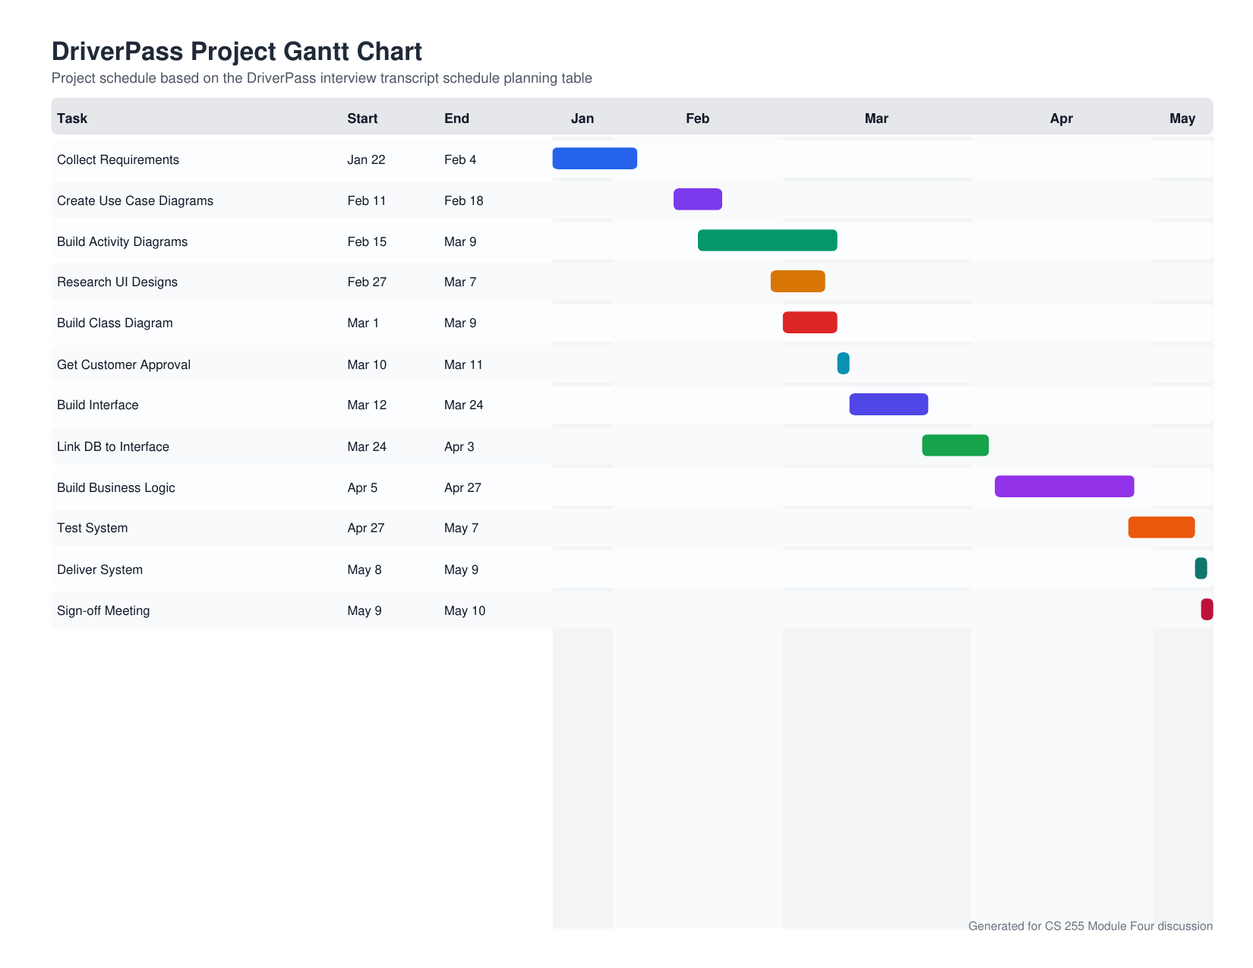

References

Southern New Hampshire University. (n.d.). CS 255 DriverPass interview transcript. Brightspace.
Southern New Hampshire University. (n.d.). CS 255 Lucidchart tutorial. Brightspace.

